What Are You Saved for?

We are saved from hell and the wrath of God. We are saved to enter a heavenly kingdom. That is our destination. John 17 tells us what we are saved for. That is our destiny once we reach our destination.

1. To know God & Jesus (3, 12, 25-26)

A. To know God as our Father

B. To know Jesus as the eternal Son

2. To see and share the glory of Jesus (1-5, 22, 24)

A. The honor of Jesus

B. The splendor of Jesus

3. To be united to God and Jesus (21-23)

A. A union formed by the Holy Spirit
John 14:16-17, 23

B. A union that preserves individual identity

4. To be filled with God’s love for Jesus (26)

A. God’s Love enters us in the Holy Spirit

B. We love God with His own Love

Application

A. Come to Christ and to be saved for this destiny

B. Commune with the Spirit to long for this destiny
Romans 8:23-25
For Private Meditation or Family Discussion

1. What did Moses long to see, and what did the Lord grant him (Exodus 33:18-23)?
Though Moses could not see God in all His glory, how does the Bible describe his conversations with the Lord at the temporary tent of meeting (Exodus33:7-11) and later at the tabernacle (Numbers 12:6-8)?

2. What does Scripture promise us (1 Corinthians 13:12; Revelation 21:22-22:5). How does John 17:20-26 go beyond this?

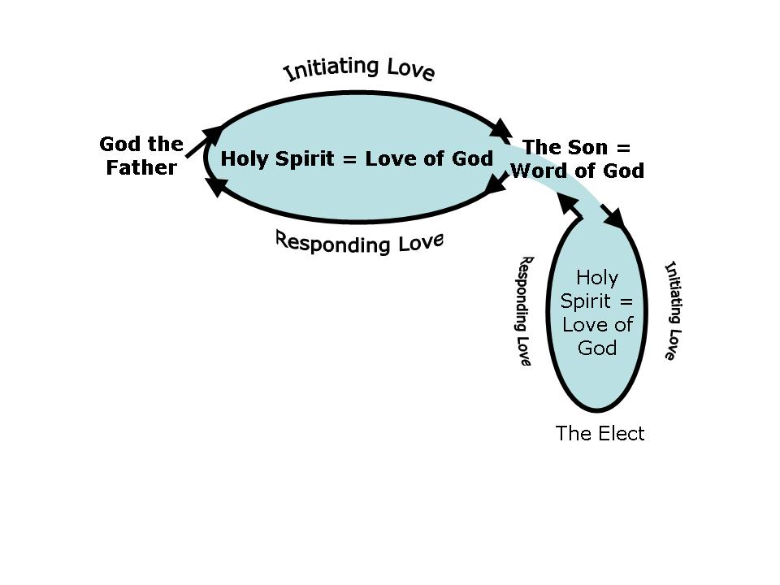
3. Diagram of John 17:21-26 with the Holy Spirit identified as the Love of God (as Christ is the Word of God).

God in us = His Spirit in us (John 14:17, 23; 1 John 3:24; 4:13).
God in us = His Love in us (John 17:21, 26; 1 John 4:12)
So, God’s Spirit in us = God’s Love in us

God demonstrates His love
by giving His Son to die for us (Rom 5:8).
God imparts His love
by giving His Spirit to live in us (Romans 5:5).

John 17 (to the tune of Face to Face)

Christ is in the Holy Father,
And the Father dwells in Him.
Through the Spirit they are living
In my heart, and I in them.

Chorus
Now united to my Savior
Bound together by His Love,
Bound together by His Spirit,
Bound for glory up above.

Jesus loves the Holy Father,
For the Father loves the Son.
And that Love, who is the Spirit,
Will perfect me when He’s done.

Glory to the Holy Father,
Glory to the Holy Son,
Glory for the holy children,
Of whom I am gladly one.

By John K. LaShell (2014)

