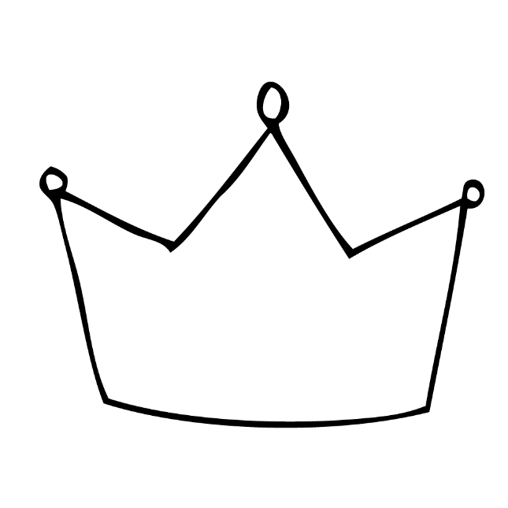  God’s Sovereignty | 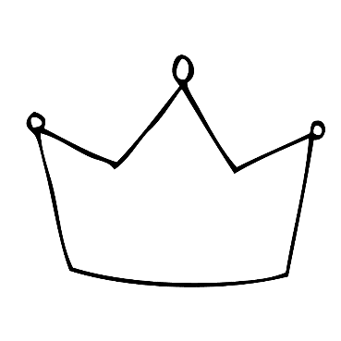  Our Rebellion | God’s Just Judgment
Jesus’ Obedience unto Death | Jesus’ Resurrection as Reigning Lord | Two Ways to Live
I encourage you to download the “Share Your Faith” and “Two Ways to Live” apps for IPhone & Android.

Suggestions for creating a bridge diagram using Romans 5 and Romans 10.
1) Draw the gulf between US and GOD. “God made us for a relationship with Himself, but something has gone wrong so that we are not able to be as close to Him, as we should be. Romans 5 describes what is wrong and why we are separated from God.” Draw the stick figure on the left.
2) Point out the words “Helpless,” “Ungodly,” Sinners,” and “Enemies” that describe us and list them under US.
3) “Since we are helpless and ungodly, all our efforts to reach God fail.” Draw the dotted downward arrow on the diagram.
3) Point out the word “wrath” that describes God’s attitude toward our sin and write it on the diagram.
4) “Death and Hell” are what we would naturally experience as a result of God’s wrath. Write “Death/Hell” at the bottom of the diagram.
5) Point out the word “love” that describes God’s attitude toward us and write it on the diagram.
6) Point out the words “Christ died” and draw the cross. “How can we cross the bridge created by Christ’s death to reach God?” Draw the middle stick figure.
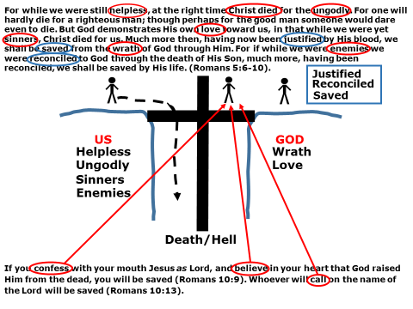
7) Turn to Romans 10 and point out the words “confess,” “believe,” and “call.” Write them on the diagram, and draw some arrows toward the stick figure. “Have you done this? Do you want to do this now?”
8) “If you have confessed Christ as your God and Master, and if you believe that God raised Him from the dead, and if you have called on Him to save you, then Romans 5 describes your standing before God now.”
9) Draw the stick figure on the right.
10) Point out the words “Justified,” “Reconciled,” and “Saved,” and write them on the diagram.

